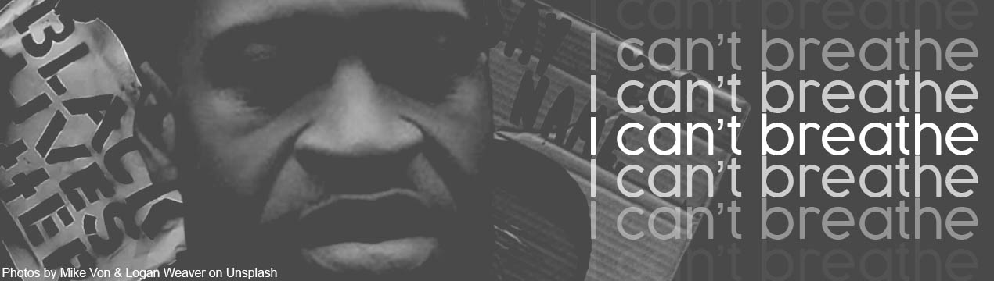

… protest is an essential part of our (church) inheritance. Surely our various traditions and theologies all demand that we also speak out and stand in solidarity with black and brown communities still experiencing institutional racism in North America – as indeed in our own country where in the aftermath of the institutional racism presented in spaces such as the Hostile Environment, Grenfell Tower fire, the Windrush Scandal, and more latterly Covid 19, many people of colour can barely ‘breathe.’

God is no neutral observer in matters of justice, racial or otherwise. God sides against injustice, with countless numbers of people of colour in this country and, everywhere, where people cry out in pain: “I can’t breathe ...”

Wale Hudson-Roberts is the Justice Enabler of the Baptist Union of Great Britain

No, O people, the Lord has told you what is good,
and this is what he requires of you:
to do what is right, to love mercy,
and to walk humbly with your God.
(from a book in the older part of the Bible)

